**BO’NESS UNITED COMMUNITY FOOTBALL CLUB**

**INTRODUCTION**

Thank you for getting in touch regarding your child’s interest in becoming part of Bo’ness United Community Football Club (BUCFC). Please find below all the information you will need regarding volunteer community football in Bo’ness.

BUCFC provides football for both boys and girls of all abilities in teams from age groups from pre-school to under 18 for boys and girls.

BUCFC currently has the SFA Legacy Award Quality Mark and are Registered Charity (SCO49321) we play football in following areas Central Region, West Lothian and South east for boys and girls.

BUCFC offers recreational football on a Friday night via McDonalds programme (mixed) KDM Girls Soccer Centre, as well as ladies’ football

BUCFC have created a football pathway for boys linking with Bo’ness United to create an under 20’s and pursuing more club partners along with both Saturday and Sunday Amateur Football, so opportunities for boys all the way to lowland league football.

BUCFC Have created a girl’s pathway from under 7 to Under 18 girls we have plans to create a Development Ladies team to continue the progress of Girls provision

BUCFC Work closely with Rangers Soccer Academy, Hearts and Hibs in the community and club partner Scoreboard soccer along with Kevin Thomson academy.

BUCFC were voted SFA Grassroots Community Football Club of year 2022.

BUCFC were voted UEFA Grassroots Bronze Award 2022/23

BUCFC were Awarded the McLaren Trophy from Bo’ness Community Council 2023.

**MY CLUB HUB**

Teams are set up within an age group with volunteer coaches and age group secretaries to oversee the smooth running of individual teams.

The first 2 weeks will be on a ‘come and try it’ basis and will have no charge. After this you will be invited to download an app to your phone or PC. The app is called my club hub (MCH)

Once you have downloaded the app you will be invited to join MCH via email to your specific child’s age group

Within this app you will find the specific club information

**Club consent forms** for your child and you as parent/guardian of child to agree to always follow and completed by adult.

**Direct debit mandate** to be completed by yourself and these donations be taken from account on 1st day of every calendar month, if you are not fee payer, we will need a secondary contact to be added to MCH.

**Gift aid** allows the club to process gift aid to support club via a tick of a box on mandate.

**All** club specific policies can be found on MCH, closed Facebook page under Files or by visiting the club website www.bucfc.com.

**TRAINING**

We have introduced a training kit which can be purchased after the trial period is complete. This training kit is compulsory and gives our children an identity and the feeling that they belong to part of our club. The training kit can be purchased via club shop and players can be sized on kits before parent’s order via club online shop by [www.bucfc.com](http://www.bucfc.com) and clicking on club shop following directions given by team secretary – i.e., squad number and sizes.

Football boots are not compulsory during trial periods. Please note that after registering at the club the wearing of shin guards and boots is required. Molded football boots / studded football boots are suitable for grass pitches. Astroturf trainers / molded football boots for AstroTurf pitches. Metal studded football boots are not permitted on Astroturf pitches.

Summer training is normally on grass at our training ground at the Murries (Muirhouses), Bo’ness or at Newtown Park 3G pitch. Winter training is normally at Newtown Park Astroturf. /Bo’ness Academy Astro

Training times will be provided for you by the team secretary. Children should be brought and collected by a responsible adult (over 16 years of age) who is known to the child. If you are unable to collect your child or find you are running late, please contact your coach or team secretary.

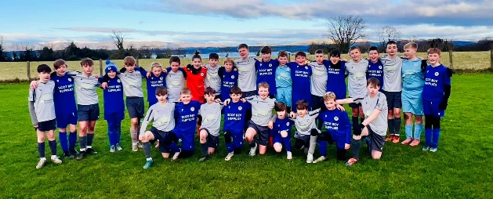

**Competitive/NON-Competitive matches**

**Mixed Age groups**

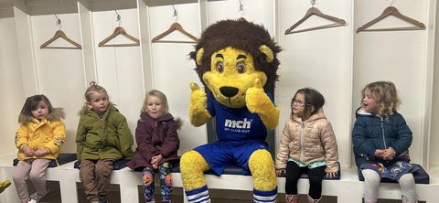

Little Leos’ program is preschool-based on fun football for young footballers on a Sunday morning. This group is the most important group of clubs as these players are the future of the club and mix with boys and girls playing football together, when players leave this age group it is their choice what pathway they follow.

Little Leos is named after the club mascot.

**BOYS SECTION.**

Boys Teams at age groups 2018 –2012 will be entered into a league playing fun, developmental football in a non-competitive environment every weekend and an occasional weeknight.

Age group 2011 – 2007 will play 11 a-side football in a competitive league. We will advise you of which league your child will be playing in and where games will be played.

**GIRLS SECTION.**

Girl’s provision of under 8 age groups won’t play in league format at non-competitive more as arrangement of fixtures,

Under 10-12’s will play in a noncompetitive league set up no trophies at end of season

girls under 14-16-18 will be classed as competitive and compete in league set up

***Player Registration***

Player registration will take place after the trial period has been completed. SYFA /SWF Registration Form, The Consent Form and Code of Conduct will be signed via MCH acceptance. The training kit can be purchased via the club shop, or an agreement is in place with the team secretary.

***If you decide to leave***

If you decide to leave, please notify your team secretary. All match day kits, and other items provided by the club must be returned and all fees paid up to date before your child can officially be released by the club and SYFA/SWF to play elsewhere. The training kit can be kept by the player.

***Child Protection***

As volunteers working with children, we are legally required to have the correct safeguards and policies in place, to keep football safe and fun for everyone in the club. We have one Child Protection Representative in each team who reports to our Child Protection Officer who ensures all our volunteers are recruited responsibly, trained appropriately and show good practice in all aspects of football coaching.

It is important that parents / carers have an awareness of the good practice we promote in our club. We have a Code of Conduct which all players, parents and supporters must adhere to. Providing children with positive sporting experiences means that they will be more likely to achieve their true potential.

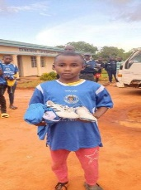 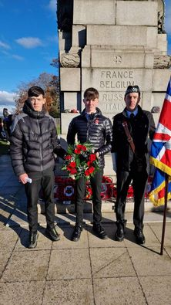

**Community Programmes**

We are deep rooted in local community collaborating with local primary schools and active schools to provide free training for local children, we also make donations to local foodbanks and other organisations doing great work in local community like salvation army and our charity sponsor Barnardo’s Scotland.

Further afield we support Banana box trust in Dundee who deliver kit to Malawi Africa for children along with SFSA to support adults in Malawi

We also organise preloved football boots for our players and beyond and in future we will be organising football memories programmes to help elderly in community who like football.

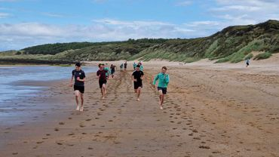

**BUCFC POINTS OF CONTACT.**

BUCFC is managed by a voluntary committee. We are here to help you and assist in many ways:

Club emails are as follows.

[Info@bucfc.com](mailto:Info@bucfc.com) – for general club enquiries

[Treasurer@BUCFC.com](mailto:Treasurer@BUCFC.com) – for enquiries into fee payments

[Compliance@BUCFC.com](mailto:Compliance@BUCFC.com) – for all information on complaints and child protection / wellbeing.

[Community@BUCFC.com](mailto:Community@BUCFC.com) – for all information on Bucfc community work from fundraising events to working with local schools and partners.

[media@bucfc.com](mailto:media@bucfc.com) for all information on Bucfc newsletter and promotional work.

[clubdevelopment@bucfc.com](mailto:clubdevelopment@bucfc.com) for all club main business and day to day tasks

[Chair@BUCFC.com](mailto:Chair@BUCFC.com) – to email Bucfc Club Chairman directly.

***Communication***

We use many methods of communication, all fully supported by the SYFA/SWF

Messages sent by team secretaries / coaches for game times / locations can be sent via text. MCH, Facebook messenger, what’s app spond and other social media outlets with full agreements in place to protect all users in line with social media policy

Club Website [www.bucfc.com](http://www.bucfc.com)

Twitter - bonessunitedcfc

Facebook – Bo’ness United Community Football (closed group)

Bo’ness united community FC

Instagram -bucommfc

Linkedin- Bo’ness United Community fc

Updated Jan 2025

Reviewed May 2025.